Project 2

Complete Project Report

Submitted by,

1. Kaushik Pulivendula Balasubramanyam 1001529713
2. Subrahmanya Basavapatna Nagaraja Rao 1001540208

**PseudoCode of converting csv files into JSON, Inserting them into MongoDB and then creating two documents.**

import csv

Import json

From pymongo, import MongoClient

Import system, getoutput, pprint

// Database connection

Connection = MongoClient(‘local host’, 27017)

Print db connected success message

// Create JSON file from given CSV input

Create JSON

Assign Team, stadium, Players, game, Starting lineup’s, Own goals to files

Specify directory Address

For file in files

Assign csv files to input file

Specify JSON file as output file

Open csv input file ‘r’

Open JSON outfile, w and assign it to JSON file

Declare fieldnames = ‘ ‘

If file == ‘Team’

Assign Teamid, Team, Continent, league, population to fieldnames

If file == ‘stadium’

Assign SID, SName, SCity, SCapacity to fieldnames

If file == ‘players’

Assign player attributes to fieldnames

If file == ‘Game’

Assign Game attributes to field names

If file == ‘Starting_lineups’

Assign Starting-lineups attributes to fieldnames

If file == ‘Goals’

Assign Goal attributes to field names

If file==’Own_Goals’

Assign Own_Goals attributes to field names

Read csv files with fieldnames and assign it to reader

Parse each row of csv file and convert it to JSON file

//Insert JSON file into Mongo DB

insertIntoDB();

Declare files with ith its attributes

Assign correct location in directory

For file in files

Input file is .JSON file and open input file

If file == ‘Team’

Soccerdata is connected to mongo db

Declare Team attributes and assign it to fieldnames

Insert attribute values to each row

If file == ‘Stadium’

Soccerdata is connected to mongo db

Declare Stadium attributes and assign it to fieldnames

Insert attribute values to each row

If file == ‘Game’

Soccerdata is connected to mongo db

Declare Game attributes and assign it to fieldnames

Insert attribute values to each row

If file == ‘Stadium’

Soccerdata is connected to mongo db

Declare Stadium attributes and assign it to fieldnames

Insert attribute values to each row

If file == ‘Goals’

Soccerdata is connected to mongo db

Declare Stadium attributes and assign it to fieldnames

Insert attribute values to each row

If file == ‘Starting_Lineups”

Soccerdata is connected to mongo db

Declare Starting_Lineups attributes and assign it to fieldnames

Insert attribute values to each row

If file == ‘Players’

Soccerdata is connected to mongo db

Declare Player attributes and assign it to fieldnames

Insert attribute values to each row

If file == ‘Goals”

Soccerdata is connected to mongo db

Declare Goals attributes and assign it to fieldnames

Insert attribute values to each row

Print Mongo db success message

//Create Team_Scores Document

createDocumentTeam_Scores()

Fetch all TeamID info and assign it to getAllTeam

For teamid in getAllTeam

Fetch Team name, Stadium Name and stadium City and assign it to stadiumDetails

Fetch match results and assign it to stadiumDetails

Declare match list and have array assigned to it with attributes team1, team2, team1 score. Team2 score, date, team1 name, team2 name, stadium name and stadium city

Append matchList

Insert into Match_Results

team,teamid, Details

If_name_ = ‘_main_’;

createJson();

insertIntoDB();

createDocumentMatchResults();

**Demonstration of MongoDb :-**

1. First we need to install mongoDB into our system, then open the command window and change directory to C:\Program Files\mongodb\bin . Then type mongo as follows :-

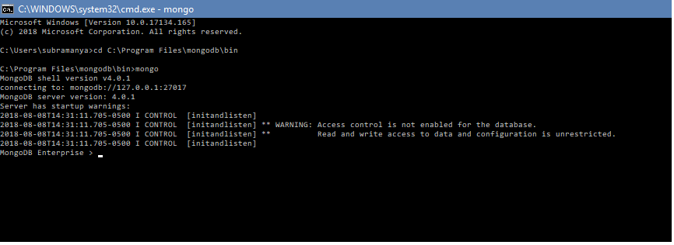

2. Then create a database using “use test”. Then create a collection in the database created by typing “db.createCollection(“Kazerine”).

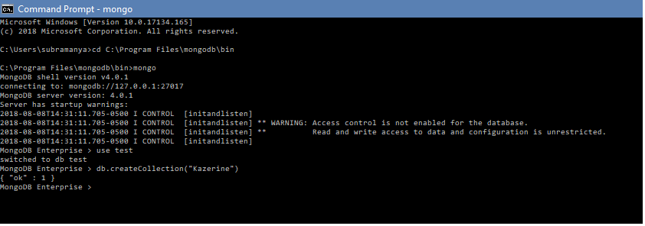

3. Insert a record using insertOne method in the created collection “Kazerine” using db.Kazerine.insertOne( { Fname : “Kazuya”, Lname : “Mishima”} )

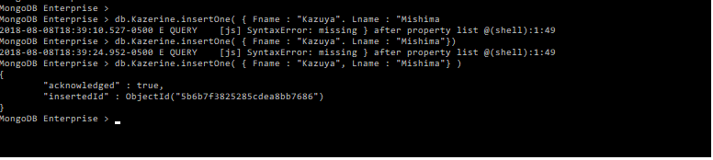

4. To display the record created inside the collection, type db.Kazerine.find({ })

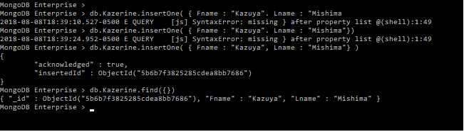

**Data Structures used :-**

**1. CSV** and **JSON** modules are imported.

**2.**  Various **file operations** are used to extract data and to write data.

**3.**  **File** data structure is used to hold the field names of the files.

**4.**  **Reader** object is used to read data from CSV files.

**5.**  **Connection** object is used to connect to MongoDb.

**NOTE :** The provided input files are converted from .txt to .csv and then converted into a JSON file.